**Segmentation**

1. Dataset

The dataset which contains the real images and the mask equivalent was obtained from <https://ieee-dataport.org/open-access/indian-diabetic-retinopathy-image-dataset-idrid>,

The data structure is as show below

We have the original image

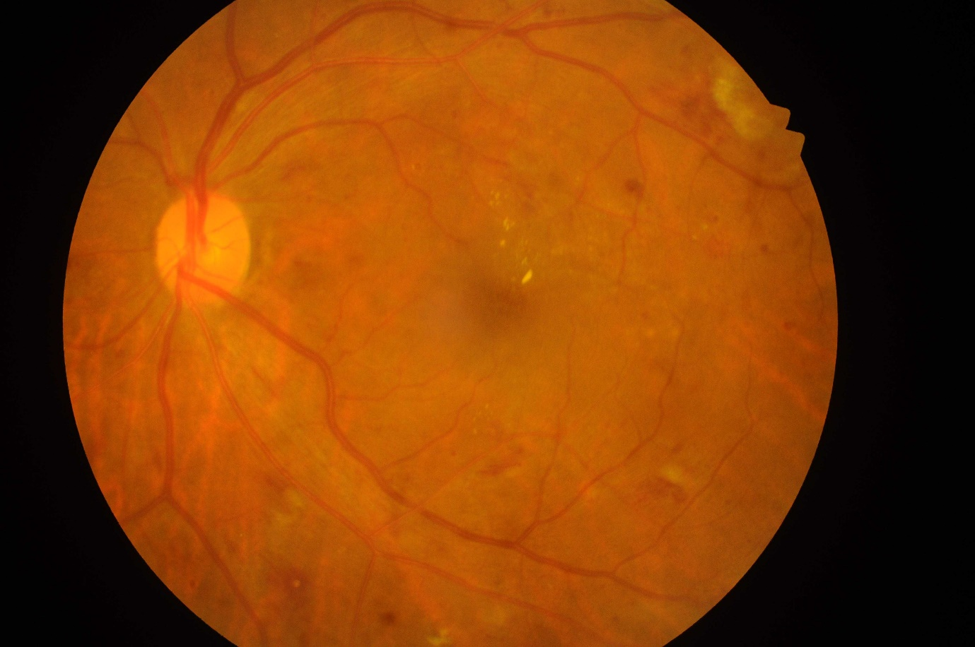

The mask:

1. Haemorrhages



1. Hard Exudates



1. Microaneurysms



1. Optic Disc



1. Soft Exudates



1. **Segmentation method**

For our segmentation, the technique used is called GrabCut. We make use of the inbuild opencv algorithm to perform this technique.

How the GrabCut works:

It works by,

* Accepting an input image with a mask that approximated the segmentation
* Iteratively performing the following steps:

1. Estimating the color distribution of the foreground and background via a Gaussian Mixture Model (GMM)
2. Constructing a Markov random field over the pixel’s labels (i.e., foreground vs. background)
3. Applying a graph cut optimization to arrive at the final segmentation

Below are the results from each mask:

**Haemorrhages**

1. mask



1. Probable Foreground

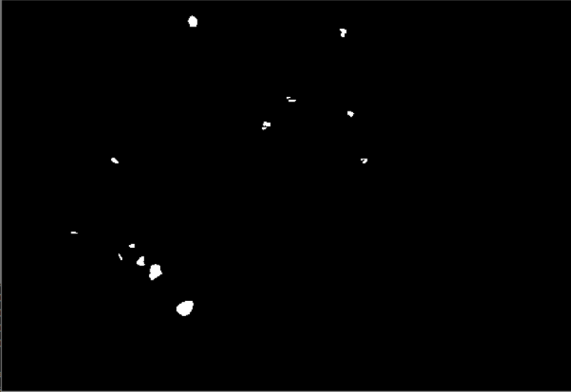

1. 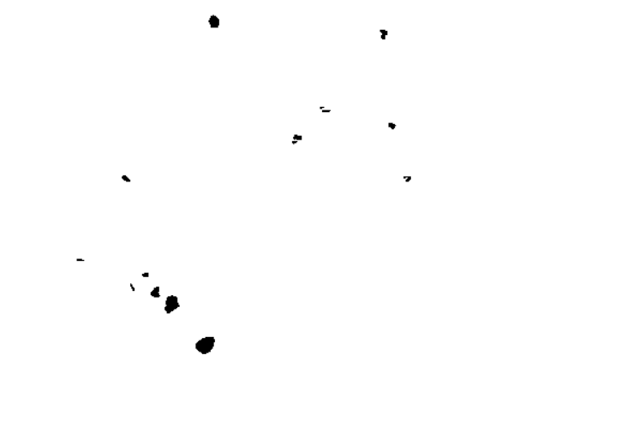Probable Background
2. Segmentation Output

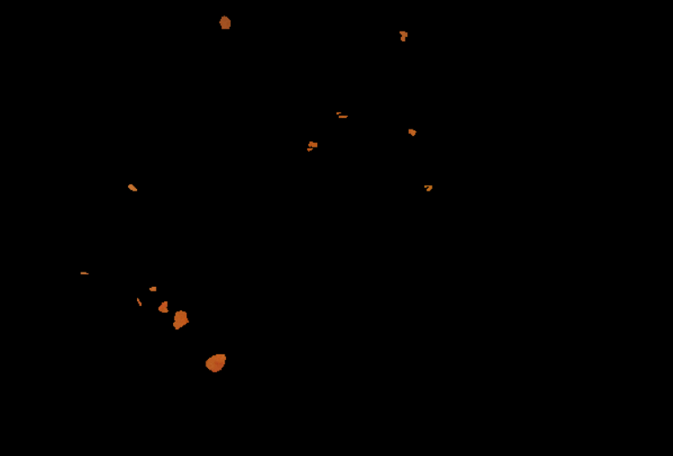

**Optic Disc**

1. mask



1. 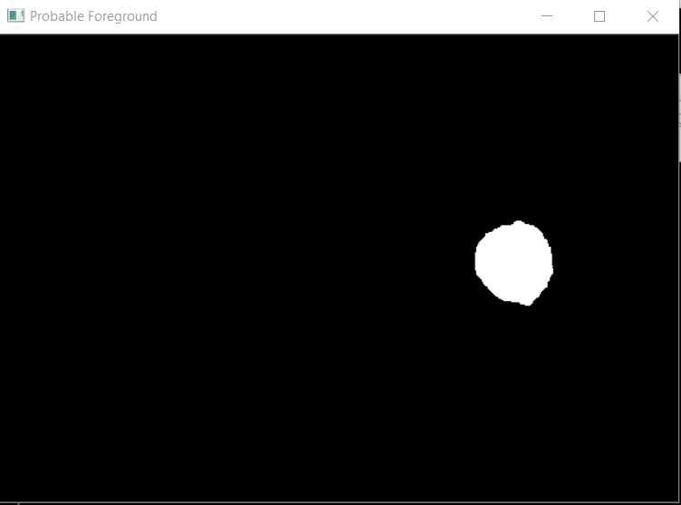Probable Foreground
2. 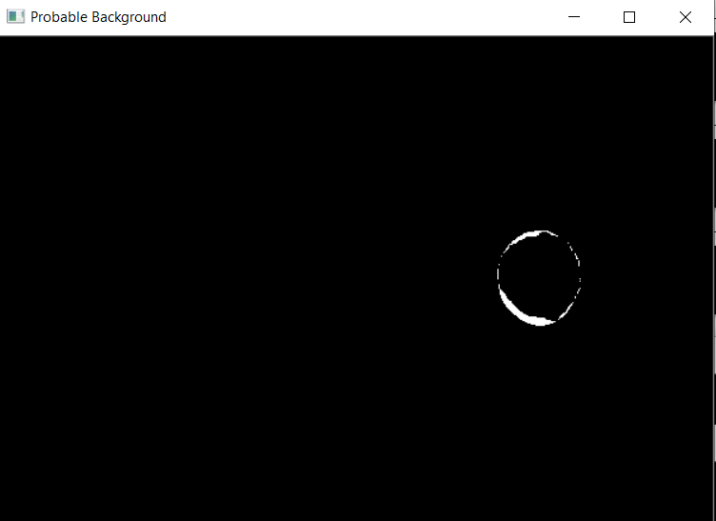Probable Background
3. 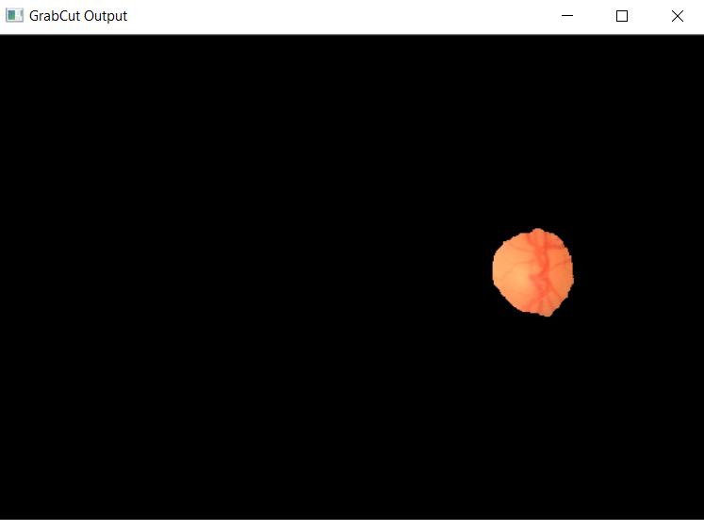Segmentation Output

**Microaneurysms**

1. Mask
2. 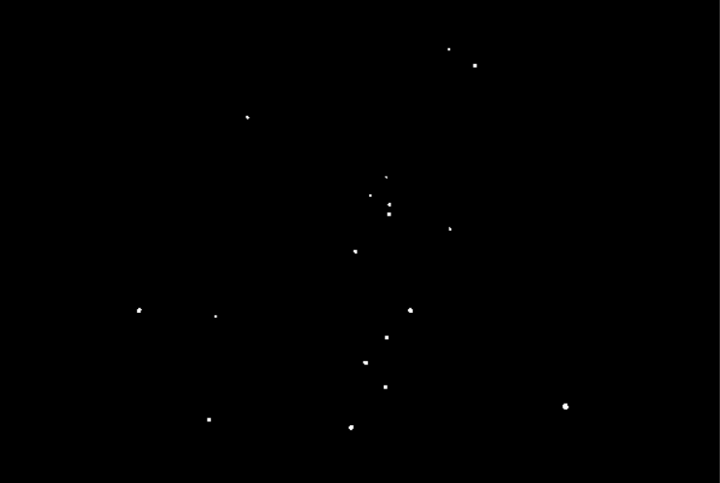Probable Foreground
3. 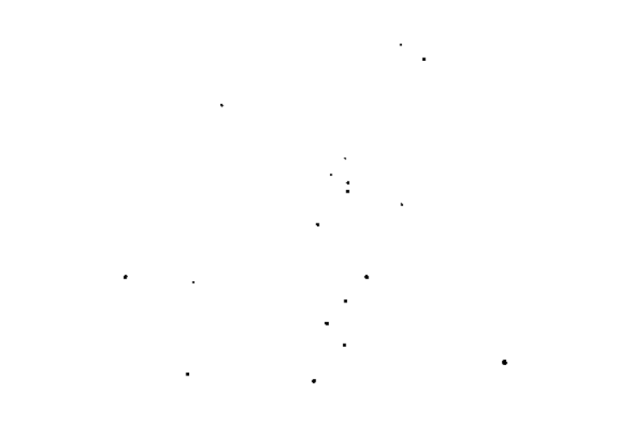Probable Background
4. 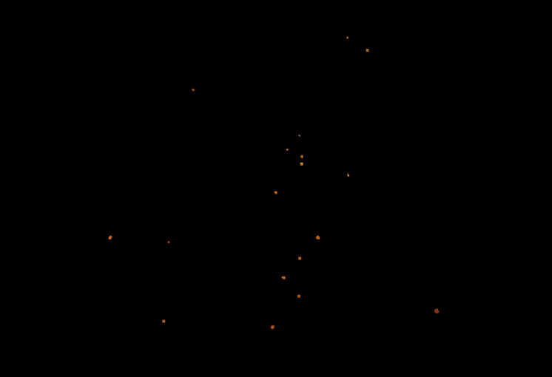Segmentation Output

**Soft Exudates**

1. Mask
2. 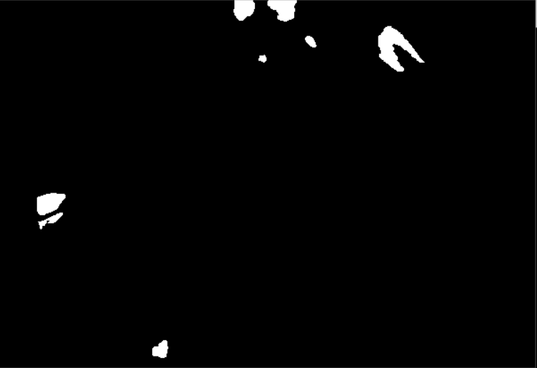Probable Foreground
3. 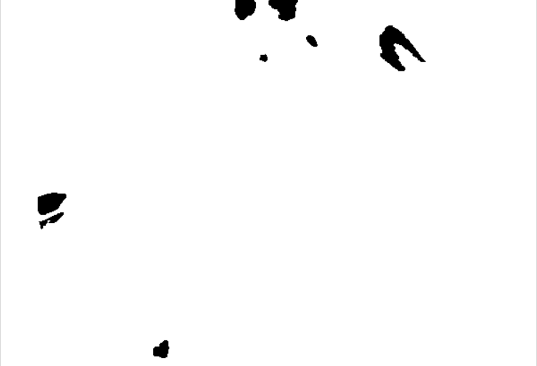Probable Background
4. 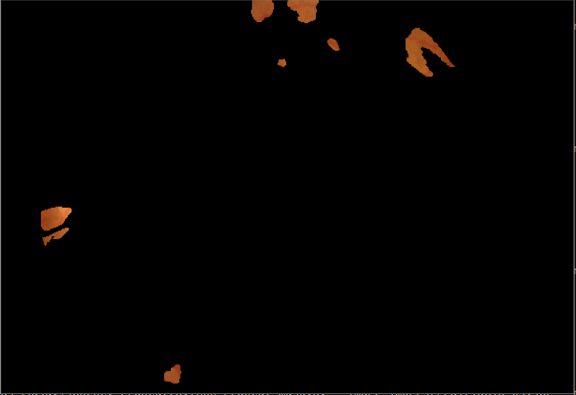Segmentation Output

**Hard Exudates**

1. Mask
2. 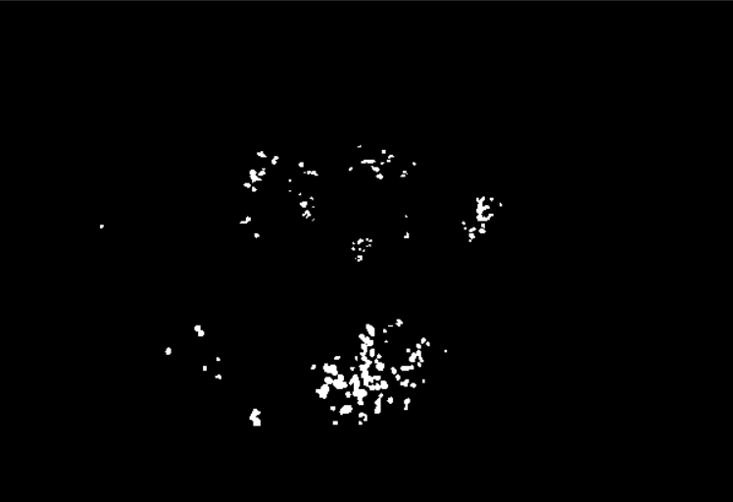Probable Foreground
3. 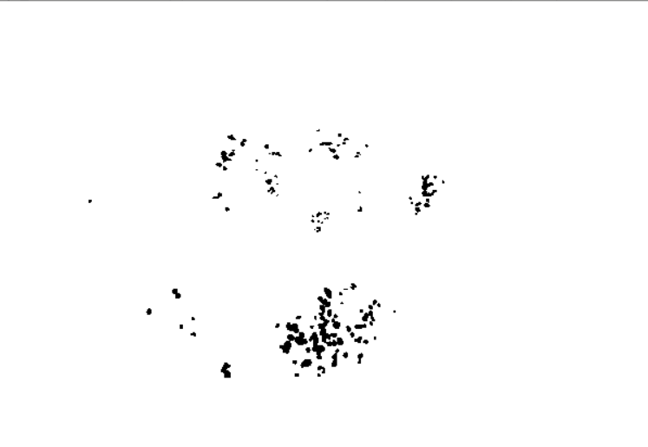Probable Background
4. 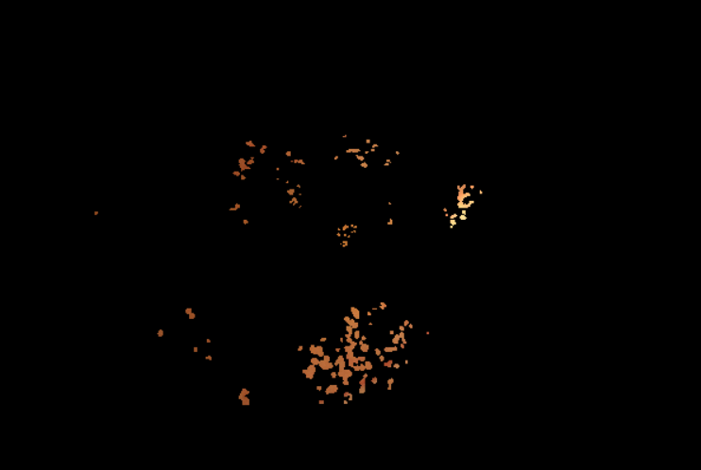Segmentation Output